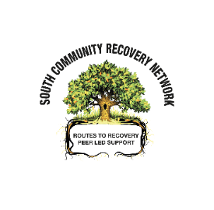
Monday
IBROX RECOVERY CAFÉ
Recovery Meeting, Table Tennis, Bingo, Connection
630pm – 830pm Broomloan House Study Centre, 150 Edmiston Drive, G51 2XD

Tuesday
WOMEN’S GROUP
Welcome, Feelings Check, Acupuncture, Monthly Recovery Meeting, Prize Bingo
1030am – 130pm The Adelphi Centre, 12 Commercial Rd, Gorbals G5 0PQ

ALCOHOL FOCUS GROUP
Group work (various topics), Presentations, Quiz, Prize Bingo
2pm – 4pm The Adelphi Centre, 12 Commercial Road, G5 0PQ

Wednesday
GLASGOW SOUTH RECOVERY CAFÉ
Check in, Recovery Shares, Presentations, Beauty Treatments, Table Tennis, Prize Bingo
11am – 2pm Ibrox Community Complex, 80 Hinshelwood Drive, G51 2XP

Thursday
CREW
Recovery Meeting, Acupuncture, Table Tennis, Beauty Treatments, Prize Bingo
1230pm – 330pm The Adelphi Centre, 12 Commercial Road, G5 0PQ

Friday
RAFT
MAT Meeting, Table Tennis Tournament, Prize Bingo
4pm – 8pm The Adelphi Centre, 12 Commercial Road, G5 0PQ
**PLEASE NOTE CHILDREN 1ST WILL NO LONGER BE PROVIDING KIDS ACTIVITIES AT RAFT AS OF 1ST MAY 2024**

Saturday
TORYGLEN CONNECTS RECOVERY
Recovery Share, Prize Bingo, Connection
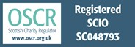
1030am – 130pm The Cornerstone Community Hall, 22 Glenmore Avenue, G42 0EH

TEA,COFFEE, FOOD PROVIDED AT ALL CAFES

Email : admin@scrn-recovery.co.uk
Telephone: 0141 429 8181

