Gone Too Soon
A group set up for anyone suffering with the loss of a loved one

Meeting every fortnight on a Thursday at the South Community Recovery Network 12-2pm
Dates

14th Sept
28th Sept
12th Oct
26th Oct
9th Nov
23rd Nov
7th Dec
21st Dec

For more information contact Marylin on
07912 582 013
admin@scrn-recovery.co.uk

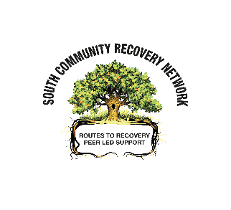
The Adelphi Centre
12 Commercial Road
Gorbals
Glasgow, G5 0PQ

